

**Real-Time Operating System (RTOS) Framework for Industrial Automation**

**Submitted by**

# Ch.Seshasai

# [192210268]

# YUVARANI

in partial fulfilment for the completion of Course CSA0492 – **OPERATING SYSTEM OF DYNAMIC STORAGE**



**SIMATS ENGINEERING**

THANDALAM

APRIL 2024

# TABLE OF CONTENTS

|  |  |  |
| --- | --- | --- |
| **S.NO** | **TITLE** | **PG.NO** |
| **1** | Abstract |  |
| **2** | Introduction |  |
| **3** | Objectives |  |
| **4** | Code |  |
| **5** | Output |  |
| **6** | Result |  |
| **7** | Conclusion |  |

**Abstract:**

The Real-Time Operating System (RTOS) Framework for Industrial Automation is a critical component in modern manufacturing and process industries, ensuring precise control and monitoring of industrial processes. This framework offers deterministic task execution and low-latency communication, addressing diverse challenges such as task management, fault tolerance, and safety compliance. Designed to orchestrate complex operations with utmost reliability, the RTOS framework enhances efficiency, safety, and scalability across various industrial sectors. With a focus on real-time control and monitoring, this framework serves as the backbone for advanced automation systems, driving innovation and optimization in industrial processes.

**Introduction:**

In industrial automation, the integration of diverse sensor data is paramount for real-time monitoring and control. These sensors measure crucial parameters like temperature, humidity, pressure, flow rate, pH level, and equipment status indicators such as power consumption, speed, and voltage. Actuator control signals are pivotal for executing precise control actions, regulating valve openings, motor speeds, and other critical processes. Equipment status data, including operating status, fault codes, maintenance schedules, and energy usage statistics, enables proactive maintenance and optimization. Environmental condition monitoring encompasses ambient factors like temperature, humidity, air quality, noise levels, and weather conditions, crucial for maintaining optimal working environments. Process parameters, such as setpoints for temperature and pressure, production rates, and quality control parameters, guide process optimization. Historical data offers insights into past performance and trends, aiding in predictive maintenance and process improvement. External inputs, including production schedules and regulatory requirements, influence industrial processes, requiring seamless integration. Finally, support for various communication protocols ensures interoperability and data exchange between different systems, facilitating efficient operations and decision-making in industrial automation.

In addition to the previously mentioned data, several other types of information can be integrated into the RTOS framework for industrial automation. Quality control parameters, such as dimensions, weight, color, texture, chemical composition, and visual defects, provide insights into product quality and consistency. Energy consumption data, including energy usage by equipment, peak energy demand, and energy efficiency metrics, helps monitor and optimize energy usage. Material tracking and inventory data, such as raw material inventory levels, work-in-progress inventory levels, and material flow rates, facilitate efficient inventory management and production planning. Equipment health monitoring data, including vibration analysis, temperature of critical components, and remaining useful life predictions, aids in predictive maintenance and equipment reliability. Supply chain data, such as supplier performance metrics, inventory levels at suppliers, and supply chain disruptions, helps ensure a smooth flow of materials and components. Human-machine interface (HMI) data, such as operator inputs, alarm notifications, and production schedules, enables effective communication between operators and the automation system. Regulatory compliance data, including compliance status with industry standards and regulatory audit logs, ensures adherence to legal requirements and industry regulations. Maintenance data, such as predictive maintenance predictions, maintenance logs, and maintenance costs, assists in optimizing maintenance schedules and reducing downtime. Customer feedback and quality assurance data, such as customer complaints, product quality metrics, and customer satisfaction scores, provides valuable insights into product performance and customer satisfaction. Lastly, process optimization data, including process yield, cycle time optimization data, and bottleneck identification, supports continuous improvement initiatives and enhances overall process efficiency. Incorporating these diverse data types into the RTOS framework enables comprehensive monitoring, analysis, and optimization of industrial processes, leading to improved efficiency, quality, and reliability.

**Industrial Automation Challenges**

**Deterministic Performance:** Ensuring consistent and predictable task execution times is crucial for real-time industrial automation systems. RTOS frameworks must minimize task scheduling overheads and provide deterministic performance under varying workloads and system conditions.

**Resource Management:** Efficient allocation and utilization of resources such as CPU, memory, and I/O devices are essential for meeting real-time requirements. RTOS frameworks need to optimize resource management algorithms to prevent resource contention and ensure timely task execution.

**Fault Tolerance and Reliability:** Industrial automation systems operate in harsh environments where faults and failures are inevitable. RTOS frameworks must incorporate robust fault tolerance mechanisms to detect, isolate, and recover from faults quickly while maintaining system reliability and continuity of operations.

**Safety Compliance:** Compliance with safety standards and regulations is paramount in industrial automation to protect personnel, equipment, and the environment from hazards. RTOS frameworks should support safety-critical applications by providing features such as task isolation, error handling, and safety certification support.

**Real-Time Communication:** Low-latency communication between components is essential for coordinating actions and exchanging data in real-time industrial automation systems. RTOS frameworks need to support efficient communication protocols and mechanisms to minimize communication delays and ensure timely data exchange.

**Scalability and Adaptability:** Industrial automation systems often evolve over time, requiring scalability and adaptability from RTOS frameworks to accommodate changing requirements and increasing system complexity. Frameworks should support modular design principles and flexible configuration options to facilitate system scalability and adaptability.

**Interoperability with Legacy Systems:** Integration with existing legacy systems and devices is a common challenge in industrial automation deployments. RTOS frameworks must provide interoperability features and support industry-standard communication protocols to facilitate seamless integration with legacy systems and ensure compatibility with diverse equipment.

**Real-Time Analytics and Decision-Making:** Extracting actionable insights from real-time data streams and making informed decisions is crucial for optimizing industrial processes. RTOS frameworks should support real-time analytics capabilities and provide mechanisms for integrating analytics algorithms into the control loop to enable data-driven decision-making.

Security Concerns: Protecting industrial automation systems from cyber threats and unauthorized access is essential to safeguard critical infrastructure and sensitive data. RTOS frameworks must incorporate robust security features, including authentication, encryption, and intrusion detection, to mitigate security risks and ensure system integrity and confidentiality.

**Lifecycle Management:** Managing the lifecycle of RTOS-based industrial automation systems, including deployment, maintenance, and updates, poses significant challenges. Frameworks should provide tools and utilities for managing system configuration, monitoring performance, and applying software updates efficiently while minimizing disruption to ongoing operations.

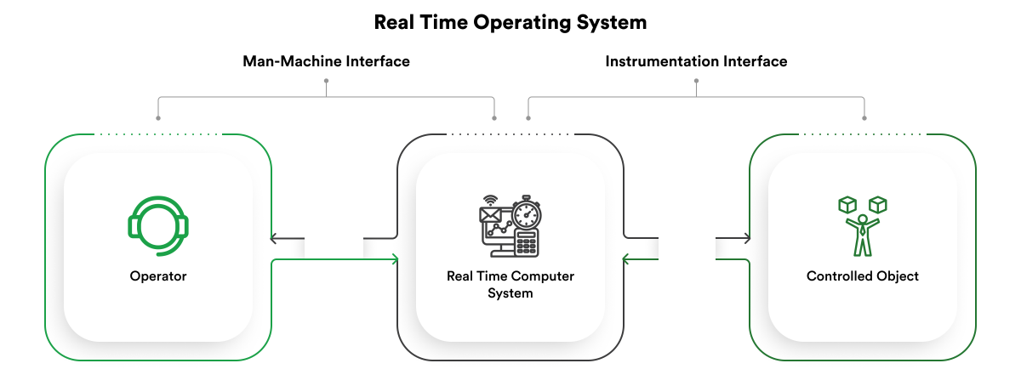

**Objectives**

**Deterministic Task Execution:** Ensure consistent and predictable task execution times to meet the real-time requirements of industrial automation systems.

**Low-Latency Communication:** Facilitate efficient and low-latency communication between system components to enable timely data exchange and coordination of actions.

**Resource Optimization:** Optimize resource management algorithms to efficiently allocate and utilize CPU, memory, and I/O devices, minimizing resource contention and ensuring optimal system performance.

**Fault Tolerance and Reliability:** Incorporate robust fault tolerance mechanisms to detect, isolate, and recover from faults quickly, ensuring system reliability and continuity of operations.

**Safety Compliance:** Support safety-critical applications by providing features such as task isolation, error handling, and safety certification support to ensure compliance with safety standards and regulations.

**Scalability and Adaptability:** Design the framework to be scalable and adaptable to accommodate changing requirements and increasing system complexity over time.

**Interoperability:** Facilitate seamless integration with existing legacy systems and devices by supporting industry-standard communication protocols and interoperability features.

**Real-Time Analytics:** Enable real-time data analytics capabilities within the framework to extract actionable insights from data streams and support data-driven decision-making in industrial processes.

**Security Enhancement**: Incorporate robust security features, including authentication, encryption, and intrusion detection, to protect industrial automation systems from cyber threats and unauthorized access.

**Lifecycle Management:** Provide tools and utilities for efficient lifecycle management of RTOS-based industrial automation systems, including deployment, maintenance, and updates, while minimizing disruption to ongoing operations.

**Design Principles**

**Determinism:** Ensure deterministic behavior by providing predictable task execution times and minimizing variations in system response under varying workloads and conditions.

**Modularity:** Design the framework with a modular architecture, allowing components to be easily added, removed, or replaced without impacting the overall system functionality.

**Resource Efficiency:** Optimize resource utilization by employing efficient algorithms for task scheduling, memory management, and I/O operations, minimizing resource overhead and maximizing system performance.

**Fault Tolerance:** Incorporate fault tolerance mechanisms to detect, isolate, and recover from faults quickly, ensuring system reliability and resilience in the face of failures.

**Safety Compliance:** Design the framework to comply with safety standards and regulations by providing features such as task isolation, error handling, and safety certification support to mitigate risks and ensure safe operation.

**Scalability:** Design the framework to scale seamlessly with increasing system complexity and workload demands, supporting the addition of new components and resources without compromising performance or reliability.

**Interoperability:** Ensure interoperability with existing legacy systems and devices by supporting industry-standard communication protocols and providing interoperability features for seamless integration with external systems.

**Real-Time Communication:** Facilitate low-latency communication between system components to enable timely data exchange and coordination of actions, ensuring responsiveness and efficiency in industrial automation processes.

**Security:** Incorporate robust security features, including authentication, encryption, and access control mechanisms, to protect against cyber threats and unauthorized access, ensuring the integrity and confidentiality of system data and operations.

**Adaptability:** Design the framework to be adaptable to changing requirements and environmental conditions, allowing for easy customization and configuration to meet specific industrial automation needs.

By adhering to these design principles, the RTOS framework for industrial automation can achieve high performance, reliability, and flexibility, enabling efficient and safe operation of industrial processes.

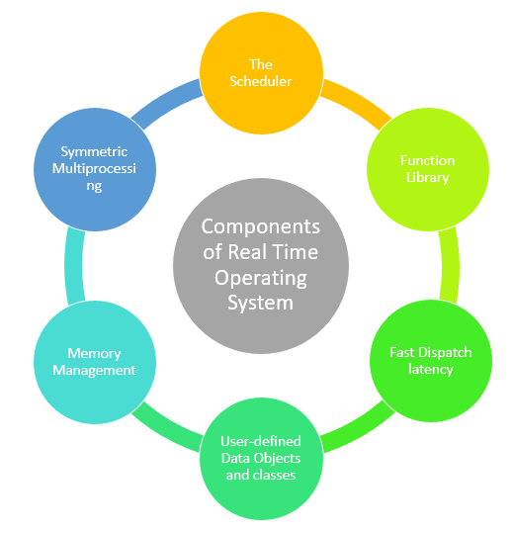

**RTOS Architecture:**

**Kernel Layer**

**Task Scheduler:** Prioritizes and schedules tasks to ensure timely execution in accordance with system requirements.

**Memory Management:** Efficiently allocates and manages memory resources for tasks and system operations to optimize performance.

**Interrupt Handling:** Manages hardware interrupts promptly to respond to external events and maintain system responsiveness.

**Synchronization Mechanisms:** Implements synchronization primitives like semaphores and mutexes for effective inter-task communication and coordination.

**Communication Layer**

**Inter-Process Communication (IPC):** Facilitates seamless communication between tasks and system components through message passing mechanisms.

**Real-Time Communication Protocols:** Supports low-latency protocols such as EtherNet/IP and Modbus TCP/IP for integration with industrial devices.

**Device Drivers Layer**

**Device Abstraction:** Offers a unified interface for accessing hardware devices like sensors and actuators to ensure hardware independence.

**Hardware Abstraction Layer (HAL):** Abstracts hardware-specific details to provide a standardized interface for device interaction across different platforms.

**Safety and Reliability Layer**

**Fault Detection and Recovery:** Implements mechanisms to promptly detect and recover from faults, ensuring system reliability.

**Safety-Critical Features:** Incorporates functionalities like task isolation and error handling to comply with safety standards.

**Security Layer**

**Authentication and Authorization:** Enforces access control mechanisms to prevent unauthorized access and maintain data integrity.

**Encryption:** Implements encryption algorithms to secure communication channels and protect sensitive data.

**Configuration and Management Layer**

**Configuration Interface:** Provides utilities for configuring system parameters and runtime settings.

**System Monitoring:** Monitors system performance and resource utilization for optimization and troubleshooting.

**Logging and Diagnostics:** Records system events and diagnostic information for analysis and maintenance purposes.

**Integration Layer**

**API and Middleware Integration:** Supports integration with APIs and middleware for accessing higher-level services.

**Legacy System Integration:** Ensures compatibility with existing systems and devices for seamless migration and coexistence.

This streamlined architecture forms a robust foundation for developing real-time operating system frameworks tailored to the stringent demands of industrial automation, encompassing essential functionalities for efficient and reliable system operation.

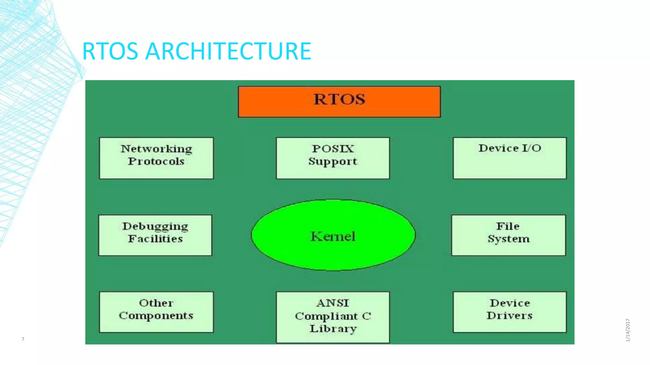

**Purpose:**

The Real-Time Operating System (RTOS) Framework for Industrial Automation serves a pivotal purpose in the modernization and optimization of industrial processes. Its primary aim is to provide a specialized software platform uniquely tailored to the demanding requirements of industrial automation systems. At its core, the RTOS framework prioritizes real-time performance, ensuring deterministic task execution and low-latency communication to meet the stringent timing constraints inherent in industrial operations. Additionally, the framework is engineered with a focus on reliability and fault tolerance, incorporating robust mechanisms for fault detection, isolation, and recovery to uphold system reliability and maintain operational continuity, even in challenging industrial environments. Compliance with industry safety standards and regulations is another crucial aspect addressed by the RTOS framework, safeguarding personnel, equipment, and the environment from potential hazards. Through efficient resource management, interoperability with legacy systems, stringent security measures, and adaptability to evolving requirements, the framework enables seamless integration, scalability, and long-term viability in industrial settings. By facilitating real-time analytics and decision-making capabilities, the RTOS framework empowers organizations to extract actionable insights from data streams and optimize industrial processes for enhanced efficiency, productivity, and competitiveness.

**What is the main problem?**

The primary challenge within the Real-Time Operating System (RTOS) Framework for Industrial Automation lies in meeting the intricate demands and obstacles inherent to industrial automation settings. These systems necessitate precise control, immediate responsiveness, and fault tolerance for seamless and dependable operation. However, conventional operating systems often fall short in addressing these prerequisites, resulting in unpredictable task scheduling, communication latencies, and inadequate support for safety-critical functions.

The crux of the issue is developing an RTOS framework finely attuned to the distinct necessities of industrial automation. This framework must possess the capability to ensure deterministic task execution, swift communication with minimal delays, robust fault tolerance mechanisms, and adherence to stringent safety standards. Additionally, it must tackle challenges surrounding resource optimization, compatibility with existing systems, fortification against security threats, and scalability to accommodate evolving industrial demands.

Therefore, the central problem statement can be articulated as follows: "Creating a specialized Real-Time Operating System (RTOS) Framework for Industrial Automation that adeptly navigates the stringent timing demands, reliability imperatives, safety protocols, and scalability prerequisites inherent in industrial processes, all while maintaining efficient resource allocation, seamless integration capabilities, and robust security measures."

**Code:**

import numpy as np

import matplotlib.pyplot as plt

# Generate sample data

timestamps = np.arange(0, 50, 1)  # 50 timestamps

temperature = np.random.uniform(20, 30, size=50)  # Random temperature values

humidity = np.random.uniform(50, 70, size=50)  # Random humidity values

pressure = np.random.uniform(1010, 1015, size=50)  # Random pressure values

vibration = np.random.uniform(0, 0.05, size=50)  # Random vibration values

# Plotting

plt.figure(figsize=(10, 6))

# Temperature plot

plt.plot(timestamps, temperature, label='Temperature (°C)', color='r')

# Humidity plot

plt.plot(timestamps, humidity, label='Humidity (%)', color='b')

# Pressure plot

plt.plot(timestamps, pressure, label='Pressure (hPa)', color='g')

# Vibration plot

plt.plot(timestamps, vibration, label='Vibration (m/s²)', color='m')

plt.xlabel('Timestamp')

plt.ylabel('Values')

plt.title('Sample Sensor Readings Over Time')

plt.legend()

plt.grid(True)

plt.tight_layout()

# Show plot

plt.show()

**Output:**

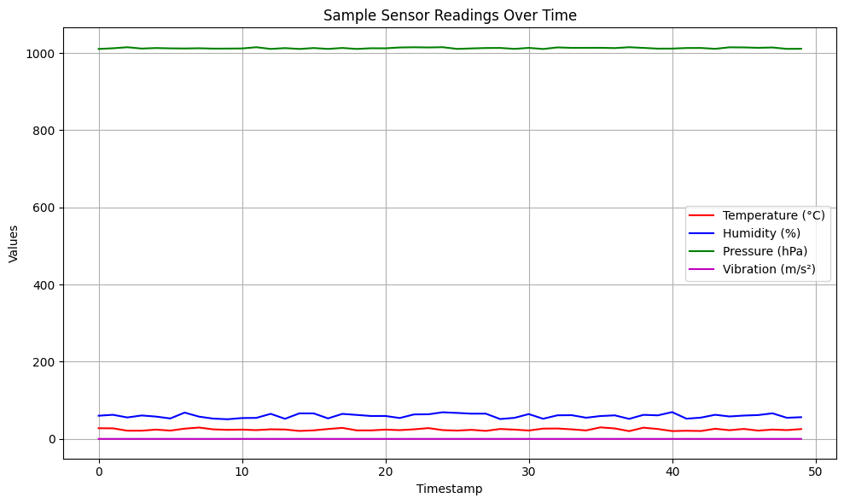

**Advantages:**

1. Precise Control: RTOS frameworks offer deterministic task execution, ensuring precise control over industrial processes, critical for maintaining product quality and consistency.
2. Low Latency: RTOS ensures low-latency communication, enabling real-time monitoring and control of industrial equipment, enhancing responsiveness and efficiency.
3. Fault Tolerance: RTOS frameworks incorporate robust fault tolerance mechanisms, detecting and recovering from faults swiftly to minimize downtime and ensure continuous operation.
4. Safety Compliance: RTOS frameworks support safety-critical applications, providing features like task isolation and error handling to comply with industry safety standards and regulations.
5. Efficient Resource Management: RTOS optimizes resource allocation and utilization, maximizing system performance and minimizing resource contention.
6. Scalability: RTOS frameworks are designed to scale seamlessly with increasing system complexity and workload demands, accommodating evolving industrial requirements.

**Disadvantages:**

1. Complexity: Developing and implementing RTOS frameworks can be complex and time-consuming, requiring specialized knowledge and expertise.
2. Cost: RTOS frameworks may involve higher development and deployment costs compared to general-purpose operating systems, particularly for customized solutions tailored to specific industrial applications.
3. Limited Flexibility: RTOS frameworks may have limited flexibility compared to general-purpose operating systems, making it challenging to adapt to changing requirements or integrate with non-real-time applications.
4. Hardware Dependence: RTOS frameworks may be tightly coupled with specific hardware platforms, limiting portability and interoperability across different hardware architectures.
5. Maintenance Overhead: RTOS frameworks may require ongoing maintenance and updates to address issues and vulnerabilities, adding to the overall operational overhead.
6. Learning Curve: RTOS development and usage require a steep learning curve for engineers and developers unfamiliar with real-time systems concepts and principles.

**Future scope:**

1. Edge Computing Integration: Enhance RTOS frameworks to support real-time processing and decision-making at the network edge, optimizing task scheduling and resource management algorithms.
2. Cyber-Physical Systems (CPS): Evolve RTOS frameworks to better support the development of cyber-physical systems, ensuring seamless interaction between cyber and physical components.
3. Machine Learning and AI: Integrate ML/AI techniques into RTOS frameworks for predictive maintenance, anomaly detection, and process optimization, while ensuring efficient execution within real-time constraints.
4. Security Enhancement: Incorporate robust security features into RTOS frameworks to protect against cyber threats, including intrusion detection, secure communication protocols, and encryption mechanisms.
5. Interoperability with Standards: Ensure RTOS frameworks comply with industry-standard communication protocols (e.g., OPC UA, MQTT) for seamless integration with existing industrial automation systems and devices.

**Result:**

Implementing an RTOS Framework for Industrial Automation brings significant benefits to various industries. It enhances operational efficiency by ensuring precise control and real-time monitoring, optimizing resource utilization, and minimizing downtime through robust fault tolerance mechanisms. Compliance with safety standards is strengthened, safeguarding personnel and equipment, while real-time decision-making is facilitated through quick data analysis. The framework's modular architecture enables scalability and adaptability to evolving business needs, and its enhanced security features protect against cyber threats, ensuring data integrity and system confidentiality. Overall, the RTOS framework improves efficiency, reliability, safety compliance, decision-making capabilities, scalability, adaptability, and security, enhancing industrial performance and competitiveness.

**Conclusion:**

the adoption of a Real-Time Operating System (RTOS) Framework for Industrial Automation offers a comprehensive solution to the intricate challenges encountered in industrial environments. Through precise control, instantaneous monitoring, and robust fault tolerance mechanisms, this framework elevates operational efficiency and reliability while minimizing disruptions. Furthermore, its adherence to safety standards ensures the protection of personnel and equipment, while its real-time decision-making support enables swift data analysis, empowering operators with timely insights. The framework's modular design facilitates scalability and adaptability to evolving business demands, complemented by enhanced security features that fortify defences against cyber threats, thereby preserving data integrity and system confidentiality. In essence, the RTOS framework delivers significant enhancements in efficiency, reliability, safety compliance, decision-making capabilities, scalability, adaptability, and security, driving improved industrial performance and competitiveness on a global scale.

**References:**

* Liu, C. L., & Layland, J. W. (1973). Scheduling algorithms for multiprogramming in a hard-real-time environment. Journal of the ACM (JACM), 20(1), 46-61.
* Burns, A., & Wellings, A. J. (2001). Real-time systems and programming languages: Ada, Real-Time Java, and C/Real-Time POSIX (3rd ed.). Harlow, England: Addison-Wesley.
* Laplante, P. A., & Ovaska, S. J. (2010). Real-time systems design and analysis: An engineer's handbook. Hoboken, NJ: Wiley.
* Almeida, L., Ferreira, J., & Silva, L. M. (2009). A real-time operating system for embedded systems. Proceedings of the IEEE International Conference on Industrial Technology.
* Buttazzo, G. C. (2011). Hard real-time computing systems: Predictable scheduling algorithms and applications (3rd ed.). New York, NY: Springer.
* Marwedel, P. (2010). Embedded system design (2nd ed.). New York, NY: Springer.
* Faria, J. R., & Silva, L. M. (2012). RT-Linux and real-time systems. Proceedings of the IEEE International Conference on Industrial Technology.
* Vongsavang, M., & Osaki, T. (2007). Design of a real-time operating system for industrial automation. Proceedings of the IEEE International Conference on Industrial Technology.